**Foam-like Electroplated Ni-W/graphene Oxide Composite Coating with High Porous Surface: An Efficient Electrocatalyst for the Hydrogen Evolution Reaction**

*Mohammad Derakhshani a, Saeed Rastegari a[1],* *Ali Ghaffarinejad b*

*a School of Metallurgy and Materials Engineering, Iran University of Science & Technology, Tehran, Iran*

*b Electroanalytical Chemistry Research Center, Iran University of Science and Technology, Tehran, Iran*

**Abstract**

In this research, the morphology of the Ni-W coating was modified by adding graphene oxide (GO) nanosheets in such a way that a foam-like structure with high porosity and holes in the form of intertwined tunnels was obtained. Different amounts of GO nanosheets were added to the plating bath and the resulting coating was examined. In order to estimate the electrochemically active surface area, the cyclic voltammetry (CV) test was used. Moreover, the linear polarization test (LSV) and chronoamperometry in 1 M NaOH were conducted to investigate the electrocatalytic activity for the hydrogen evolution reaction (HER). It was found that by adding 0.4 g/L GO to the electroplating bath, the electrocatalytic properties are doubled and the active surface of the electrode is significantly increased.

1. **Introduction**

Pollution of hydrocarbon fuels threatens human life by causing climate changes and health problems. For this reason, the development and use of clean and renewable energy are in the plans of many governments. On the other hand, the development of renewable energy can meet the ever-increasing energy demand in the world. Hydrogen is a crucial and readily available renewable energy, which is also referred to as the energy source of the 21st century [1-4].

Hydrogen is the most abundant element in the world and can be used by humans as a clean, stable, and efficient fuel. Water is the most available source of hydrogen on earth, which can be extracted and stored through electrolysis. Hydrogen is converted into electricity by a fuel cell and its output is water. In addition, another characteristic of hydrogen is its high specific energy density, producing up to three times more energy per unit volume than gasoline [5-7].

Currently, one of the main goals for the economicization of this clean energy is finding an electrode with high electrocatalytic properties to replace platinum, and many researchers are conducting investigations to address this issue [8-14]. Nickel is one of the elements that has shown good catalytic properties, and various studies have been conducted to modify its structure and increase its active surface area. Moreover, different alloy elements have been used to improve the properties of the nickel electrode [15-18]. Nickel alloys enriched with elements such as tungsten, cobalt, and molybdenum have shown promising electrocatalytic properties. This finding underscores the rationale to focus efforts on improving these electrodes [19-23].

One of the effective ways to increase the catalytic properties of the electrode is to increase the active sites on the surface and acquire a nanostructure. Creating a porous and hollow structure on the surface is recognized as the main approach to achieve this goal. Currently, many materials that have this feature exist in the form of powder. However, by adding polymer adhesives to connect the powder to the surface of the electrode, new challenges, such as the blocking of active sites and the instability of the electrode over extended periods, have been introduced [24-28].

In this research, by adding graphene oxide (GO) nanosheets to nickel tungsten coating, a unique morphology change with many foam-like pores has been observed. This morphology contains hollow cavities and interconnected channels that dramatically increase the active surface area of the electrode.

1. **Experimental procedure**

A simple carbon steel substrate with dimensions of 3 × 6 cm (The exposed surface was 3 × 3 cm) was sanded with the SiC sheet number 1000. To degrease the surface of the substrate, ethanol and acetone were used for 5 and 15 min in an ultrasonic bath. Then the samples were washed with distilled water, placed in 10% HCl solution for 20 s for surface activation, immediately washed with distilled water, and then placed in the electroplating bath with the combination given in Table 1. The GO nanosheet was homogenized by ultrasonication for 30 min and placed in the electroplating bath. The amounts of GO added to the bath and the names of the samples are listed in Table 2. The pH of the solution was 4.8, and pure nickel with dimensions of 4 × 8 cm (The exposed surface was 4 × 6 cm) was used as the anode. Plating was conducted with average current of 400 mA/cm2, 70% duty cycle, and a frequency of 100 Hz. The temperature of the bath was kept constant at 60 °C and the distance between the anode and cathode was 30 mm. Na3C6H5.2H2O and NH4Cl was used as complexing agent.

Table 1- Composition of electroplating bath

|  |  |
| --- | --- |
| 15.8 g/L | NiSO4.7H2O |
| 46.2 g/L | Na2WO4.2H2O |
| 147.1 g/L | Na3C6H5.2H2O |
| 26.7 g/L | NH4Cl |
| 15.4 g/L | NaBr |

Table 2- Amounts of graphene oxide and names of samples

|  |  |
| --- | --- |
| GO = 0.1 g/L | GO1 |
| GO = 0.2 g/L | GO2 |
| GO = 0.3 g/L | GO3 |
| GO = 0.4 g/L | GO4 |

In order to examine and compare the surface morphology of the samples, field emission scanning electron microscopy (FESEM) and X-ray energy diffraction spectroscopy (EDS) were used to determine the chemical composition of the coatings. Electrocatalytic properties were investigated using the linear polarization test (LSV) and chronoamperometry. Moreover, the active surface area of the coating was estimated by cyclic voltammetric (CV) analysis at a potential of +50 to -50 compared to the open circuit potential (OCP) at different scanning speeds from 10 to 100 mV/s. The three-electrode test was performed with a platinum electrode as the counter electrode, the coated sample as the working electrode, and calomel as the reference electrode in a 1 M NaOH solution. Additionally, the chronoamperometric test was performed at a negative cathode voltage of -1.2 V. Fourier transform infrared spectrometry (FTIR) analysis was used to investigate GO nanosheets.

1. **Results and discussion**

**3-1- Morphology and microstructure of the coating**

As can be seen in Figure 1, with an increase in the amount of GO nanosheets in the electroplating bath, the morphology of the coating is completely changed and a foam-like structure with high porosity is obtained. When GO nanosheets are incorporated into the coating during electroplating, the surface of the sheets becomes a new site for the germination and growth of the nickel-tungsten alloy. In addition, the dispersion of GO nanosheets with random directions creates a porous structure containing holes in the form of intertwined tunnels. The presence of GO nanosheets and the germination of alloy grains on them can be observed in Figure 2. The morphological changes significantly increase the active surface of the catalyst. It has also been observed that an increase in the amount of GO nanosheets in the electroplating bath corresponds to an increased number of GO sheets on which Ni-W alloy germination did not occur or was minimal. The reason for this phenomenon, which is generally observed in the surface layer and the last stage of layering, is the presence of more nanosheets and a sharp increase in suitable places for germination. The results of EDS analysis and dispersion of Ni, W, and C elements are displayed in Figure 3.

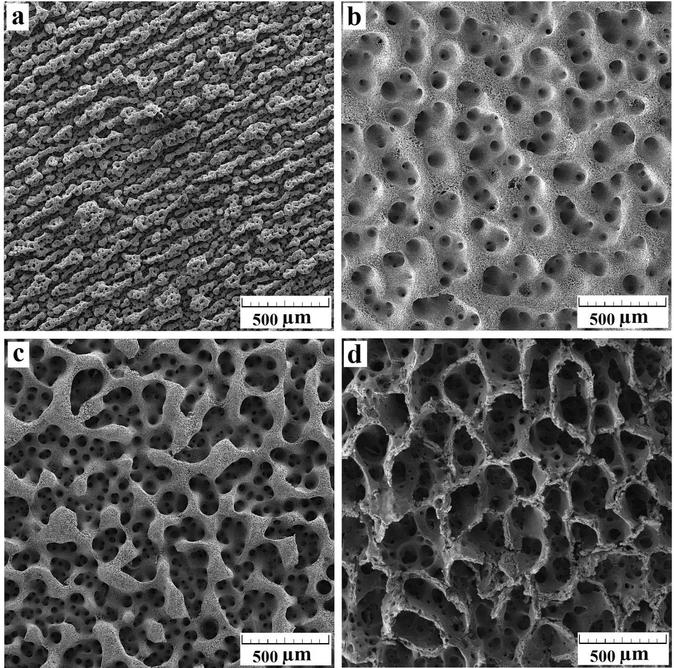

Fig. 1- SEM images related to surface morphology of Ni-W/Go coating (a) GO1, (b) GO2, (c) GO3, (d) GO4

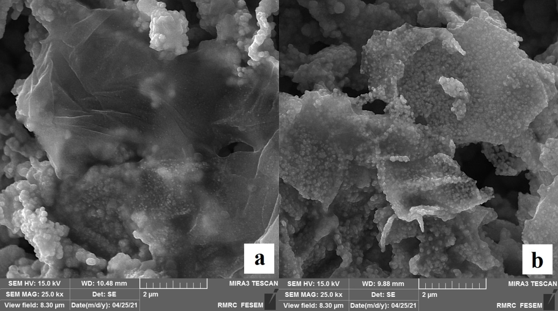

Fig. 2- (a) Graphene oxide nano sheet in sample GO4, (b) Graphene oxide nano sheet in sample GO2 and alloy germination on it.

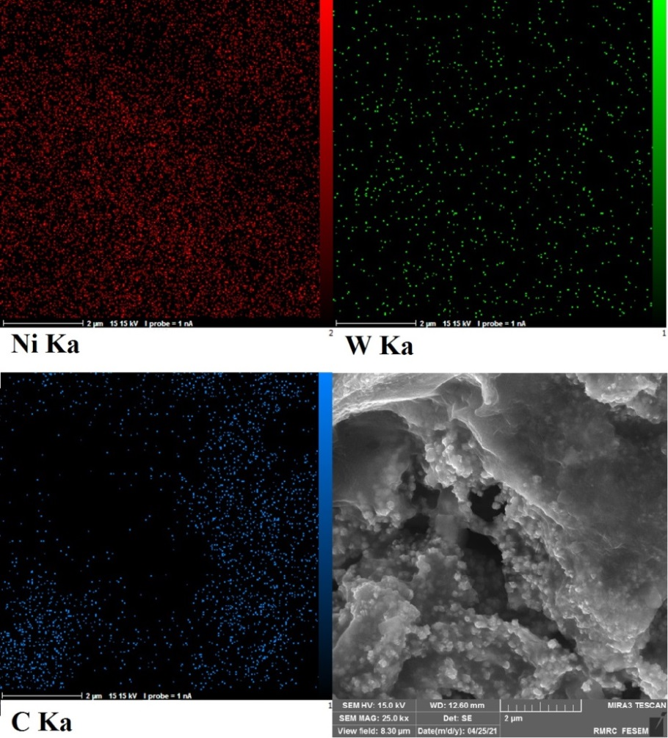

Fig. 3- The results of EDS analysis and dispersion of Ni, W and C elements.

**3-2- Investigation of electrochemical properties**

To estimate the electrochemically active surface area, a CV test is used in the range of ±50 mV compared to the OCP when there is no Faraday current. In this interval, Equation 1 applies [29]:

|jdl|= Cdl .ν (equation 1)

where Cdl is the electric double-layer capacitance, |jdl| is the capacitive current density, and ν is the potential sweep rate. At a given scan rate, the current density is calculated in the direction of movement from the OCP to positive values of the potential (janodic) and also in the reverse direction (jcathodic). Half of the obtained current density difference is the capacitive current density.

2×|jdl|= | janodic – jcathodic| (equation 2)

Figure 4 shows the results of the CV analysis. By performing the CV analysis at different scanning speeds and drawing the corresponding graphs, it can be seen that by increasing the potential scanning speed, the CV rings become larger. At the OCP, the capacitive current density is plotted as a graph in terms of the scan rate, and the slope of this graph is calculated. A higher slope of this graph indicates an increase in the capacity of the electric double layer, and consequently, a more active surface area of the electrode. In Table 3, the calculated values of the double-layer capacity are presented. It can be seen that by increasing the amount of GO nanosheets in the coating and enhancing the porosity, the electrochemically active surface area increased more than 10 times, which signifies a great improvement in the catalytic properties of the electrodes.

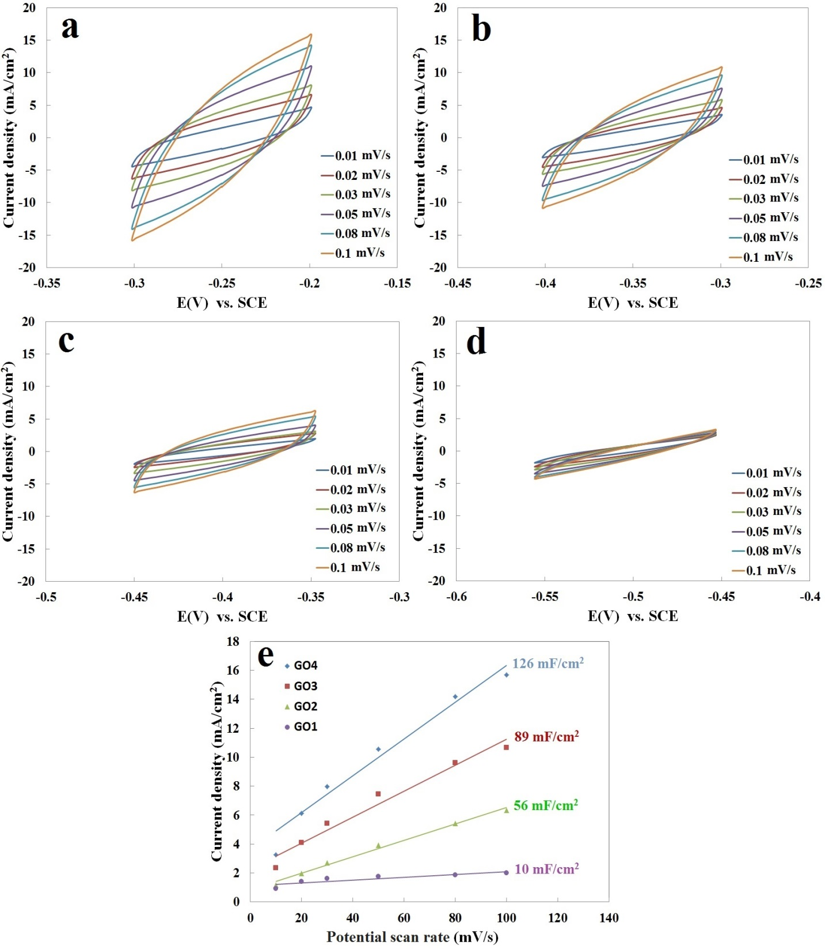

Fig. 4- Results of CV analysis of Ni-W/GO coating: (a) GO4, (b) GO3, (c) GO2, (d) GO1, (e) capacitive currents vs. scan rates of 10, 20, 30, 50, 80 and 100 mV/s in 1M NaOH.

Table 3- Estimated capacitance for different coatings

|  |  |
| --- | --- |
| **Cdl (µF/cm2)** | **Electrode** |
| 126800 | GO4 |
| 89500 | GO3 |
| 56600 | GO2 |
| 9600 | GO1 |

The LSV test results are shown in Figure 5-a. As observed, with an increase in the amount of GO nanosheets, at the same cathode potentials of the electrodes, the current values rise, and as a result, the amount of water decomposition and hydrogen production increases. These results are consistent with the results of the CV analysis. In fact, by increasing the amount of GO nanosheets in the coating and enhancing the active surface of the electrodes, the number of sites capable of electron transfer for hydrogen reduction and water splitting reaction increases, resulting in an elevation in the hydrogen evolution reaction (HER).

Figure 5-b shows that the Tofel slope in the GO4 coating is 38 mA/decade, which is lower than those obtained from GO3, GO2, and GO1 coatings (51, 58, and 109 mA/decade, respectively), and indicates the faster HER rate. The Tofel slope in GO1, GO2, and GO3 coatings is in the range of 40-120 mA/decade, which is categorized as the Volmer-Hyrovsky mechanism, and the Volmer reaction is the rate controller (Equation 3). Moreover, in the GO4 coating, the Tofel slope is in the range of 30-40 mA/decade and the Hyrovsky reaction is the rate controller (Equation 4). In the general case, there is another reaction called the Tafel reaction, in which two atomic hydrogens absorbed on the surface immediately combine with each other, and molecular hydrogen is formed (Equation 5). In this case, the Tofel slope is 30 mA/decade.

H2O + e- = Hads + OH- (equation 3)

Hads + H2O + e- → H2 + OH- (equation 4)

Hads + Hads → H2 (equation 5)

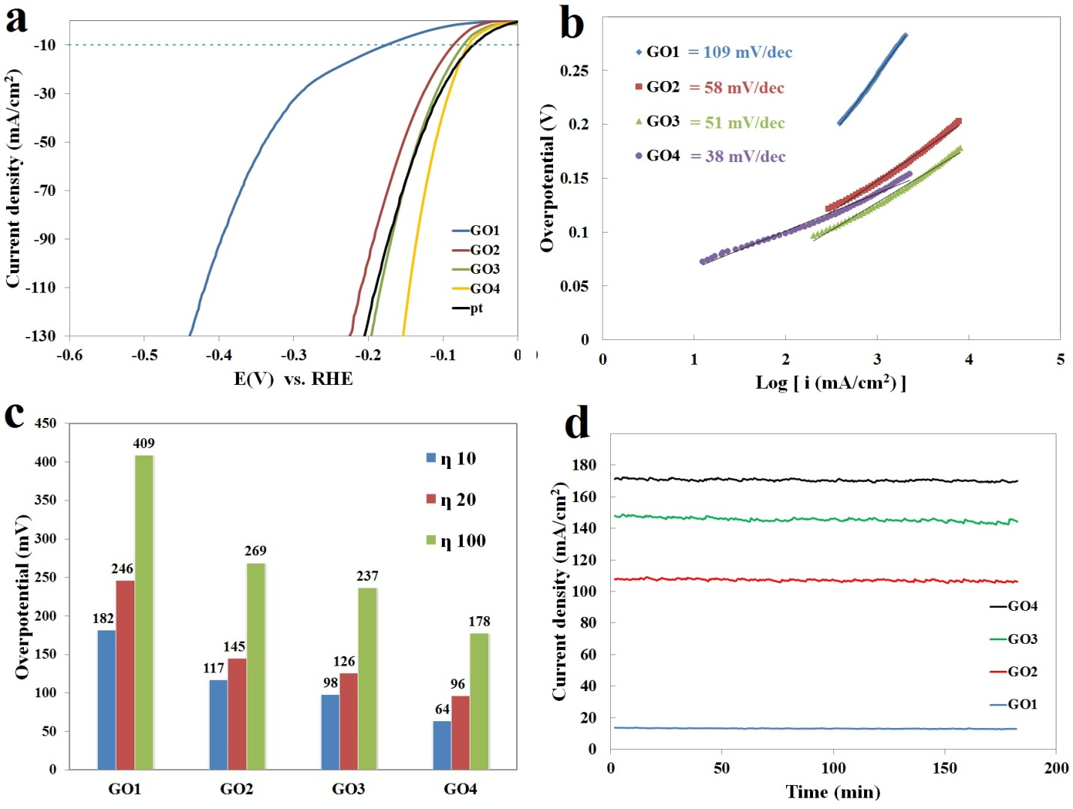

Fig. 5- Electrocatalytic properties of Ni-W/GO: a- LSV curves, b- Tafel plots, c- The overpotential required to perform the HER with a certain current density, d- Stability test results.

One method to assess the electrocatalytic activity of the samples is to measure the overpotential required to perform HER with a certain current density. In this case, the electrode has a better electrocatalytic activity that requires less overpotential to carry out the reaction. In Figure 5-c, overpotential levels needed to reach the current of 10, 20, and 100 mA/cm2 are extracted from the LSV curves. As can be seen, with an increase in the amount of GO, the overpotential to reach a current density of 10 mA/cm2 decreases, and it is lower for the GO4 coating (64 mV) than the other coatings.

The chronoamperometric test was used to investigate the stability of the electrodes, the results of which are depicted in Figure 5-d. As can be seen, the electrocatalytic properties of the samples have good stability over time, and the current recorded at a constant potential of -1.2 V vs. SCE has not shown a noticeable decrease over time. In fact, this test demonstrates that these electrodes can be used in hydrogen production for a long period of time without any significant change in efficiency.

**3-3- Structural characterization**

The results of the FTIR analysis of GO before and after the addition to the coating were compared as seen in Figure 6. The findings show that GO has functional groups containing oxygen. Hydroxyl (-OH) and epoxide are along the basal plane and carbonyl (C=O) and carboxyl (HO-C=O) are along the edges of the sheet [30]. The FTIR analysis of GO2, GO3, and GO4 coatings reveals that GO is reduced during plating; the peak at 1726 cm-1 corresponding to C=O (in carbonyl or carboxyl) has been completely removed and the intensity of the peak related to the other functional groups of oxygen is reduced. The general reaction can be expressed as follows:

2H2O → 4H+ + O2 + 4e- (equation 6)

aH+ + be- + GO → rGO + cH2O (equation 7)

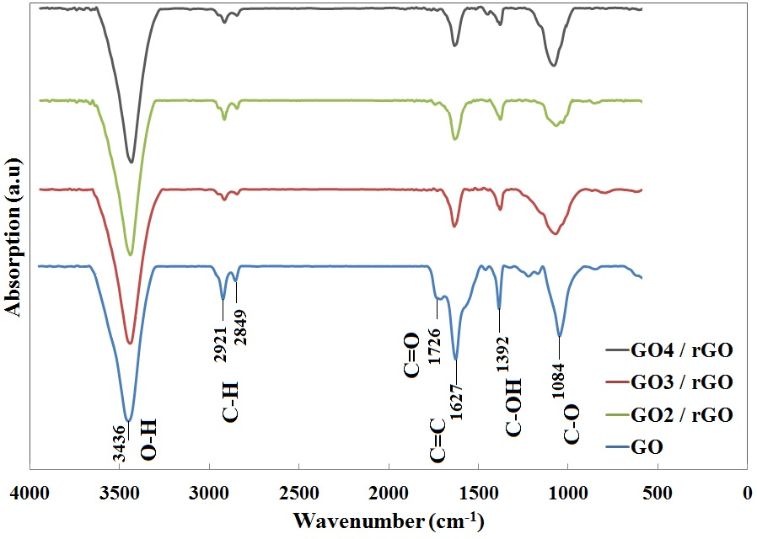

Fig. 6- The results of FTIR analysis with notable peak wavenumbers related to functional groups.

1. **Conclusion**

The Ni-W/GO porous electrocatalyst was successfully coated on a carbon steel substrate. It was observed that by increasing the amount of GO in the electroplating bath up to 0.4 g/L, the active surface of the coating increases significantly and a porous and foam-like structure is obtained. By analyzing LSV and CA, it was found that this new coating exhibits unique electrocatalytic properties for hydrogen production and the HER speed increases up to two times. Furthermore, the active surface of the coating has increased dramatically in this case. Therefore, the Ni-W/GO coating can be a suitable alternative for the hydrogen production process.

**References**

[1]. Zhang L, Xu J, Tang J, Li L, Luo J., “Synthesis self-supporting bulk porous NiMo@ MoS2 electrocatalyst to enhance hydrogen evolution in alkaline conditions.” Journal of Materials Research and Technology. 2022;17:1167-75.

[2]. Zhang H-M, Zhu C., “Co nanoparticles-embedded N, S-codoped hierarchically porous graphene sheets as efficient bifunctional electrocatalysts for oxygen reduction reaction and hydrogen evolution reaction.” Journal of Materials Research and Technology. 2020;9(6):16270-9.

[3]. Zhang Z, Lin X, “Tang S, Huang Q. WS2/NiSx heterojunction nanosheet clusters: A highly efficient electrocatalyst for hydrogen evolution reaction.” International Journal of Hydrogen Energy. 2022;47(79):33643-51.

[4]. Derakhshani M, Rastegari S, Ghaffarinejad A., “Ni-W Alloy Coating as an Efficient Electrocatalyst for the Hydrogen Evolution Reaction: Effect of Electroplating Current Density on Morphology and Electrocatalytic Properties.” Iranian Journal of Materials Science and Engineering. 2024;21(2):1-8.

[5]. Yue M, Lambert H, Pahon E, Roche R, Jemei S, Hissel D., “Hydrogen energy systems: A critical review of technologies, applications, trends and challenges.” Renewable and Sustainable Energy Reviews. 2021;146:111180.

[6]. Xiao P, Sk MA, Thia L, Ge X, Lim RJ, Wang J-Y, et al., “Molybdenum phosphide as an efficient electrocatalyst for the hydrogen evolution reaction.” Energy & Environmental Science. 2014;7(8):2624-9.

[7]. Popczun EJ, McKone JR, Read CG, Biacchi AJ, Wiltrout AM, Lewis NS, et al., “Nanostructured nickel phosphide as an electrocatalyst for the hydrogen evolution reaction.” Journal of the American Chemical Society. 2013;135(25):9267-70.

[8]. Zhang H-M, Wang J-J, Meng Y, Sun J. “Recent advances in amorphous metal phosphide electrocatalysts for hydrogen evolution reaction.” International Journal of Hydrogen Energy. 2022.

[9]. Avani A, Anila E., “Recent advances of MoO3 based materials in energy catalysis: Applications in hydrogen evolution and oxygen evolution reactions.” International Journal of Hydrogen Energy. 2022.

[10]. Han S, Li X, Zeng X, Cao D, Chen J-F., “Ru–MoS2@ PPy hollow nanowire as an ultra-stable catalyst for alkaline hydrogen evolution reaction.” International Journal of Hydrogen Energy. 2022.

[11]. Kordek K, Yin H, Rutkowski P, Zhao H., “Cobalt-based composite films on electrochemically activated carbon cloth as high performance overall water splitting electrodes.” International Journal of Hydrogen Energy. 2019;44(1):23-33.

[12]. Feng Y, Zhang S, Zhu L, Li G, Zhao N, Zhang H, et al., “Reduced graphene oxide-supported ruthenium nanocatalysts for highly efficient electrocatalytic hydrogen evolution reaction.” International Journal of Hydrogen Energy. 2022.

[13]. Verma J, Goel S., “Cost-effective electrocatalysts for Hydrogen Evolution Reactions (HER): Challenges and Prospects.” International Journal of Hydrogen Energy. 2022.

[14]. Biswas S, Das S, Jena S, Mitra A, Das S, Das K., “Pulse potentiostatic deposition of FeZn based intermetallic coatings and evaluation of its catalytic activity for hydrogen evolution reaction.” Surface and Coatings Technology. 2020;402:126299.

[15]. Uzal H, Döner A, Bayrakçeken H., “Preparation and fabrication of NiCo coated TiO2-NTs for hydrogen evolution.” Energy Sources, Part A: Recovery, Utilization, and Environmental Effects. 2022;44(2):3406-17.

[16]. Faraji H, Hemmati K, Mirabbaszadeh K., “Nickel-based nanosheets array as a binder free and highly efficient catalyst for electrochemical hydrogen evolution reaction.” International Journal of Hydrogen Energy. 2022.

[17]. Elias L, Cao P, Hegde AC., “Magnetoelectrodeposition of Ni–W alloy coatings for enhanced hydrogen evolution reaction.” RSC advances. 2016;6(112):111358-65.

[18]. Loiacono A, Diaz-Coello S, Garcia G, Lacconi GI, Rodriguez JL, Pastor E, et al., “Nickel-based composites using tungsten carbides as enhancers for electroactivity for the hydrogen evolution reaction.” Journal of Electroanalytical Chemistry. 2023:117973.

[19]. Gao Y, He H, Tan W, Peng Y, Dai X, Wu Y., “One-step potentiostatic electrodeposition of Ni–Se–Mo film on Ni foam for alkaline hydrogen evolution reaction.” International Journal of Hydrogen Energy. 2020.

[20]. Li C, Liu J, Gao R, Ouyang H, Huang J, Huang Q, et al., “Tailoring CoNi alloy embedded carbon nano-fibers by thiourea for enhanced hydrogen evolution reaction.” International Journal of Hydrogen Energy. 2022.

[21]. Allam M, Benaicha M, Dakhouche A., “Electrodeposition and characterization of NiMoW alloy as electrode material for hydrogen evolution in alkaline water electrolysis.” International Journal of Hydrogen Energy. 2018;43(6):3394-405.

[22]. Vernickaite E, Tsyntsaru N, Sobczak K, Cesiulis H., “Electrodeposited tungsten-rich Ni-W, Co-W and Fe-W cathodes for efficient hydrogen evolution in alkaline medium.” Electrochimica Acta. 2019;318:597-606.

[23]. Gao G, Wang W, Wang Y, Fu Z, Liu L, Du Y, et al., “Synergistic coupling of NiCoS nanorods with NiCo-LDH nanosheets towards highly efficient hydrogen evolution reaction in alkaline media.” Journal of Electroanalytical Chemistry. 2023:117622.

[24]. Guan C, Xiao W, Wu H, Liu X, Zang W, Zhang H, et al., “Hollow Mo-doped CoP nanoarrays for efficient overall water splitting.” Nano Energy. 2018;48:73-80.

[25]. Mahdavi S, Ranjbari P. “Using anodic oxidation for boosting supercapacitive performance of thermally-oxidized cobalt coatings with various morphologies.” Colloids and Surfaces A: Physicochemical and Engineering Aspects. 2024 Sep 20;697:134437.

[26]. Liang H, Gandi AN, Anjum DH, Wang X, Schwingenschlögl U, Alshareef HN., “Plasma-assisted synthesis of NiCoP for efficient overall water splitting.” Nano letters. 2016;16(12):7718-25.

[27]. Tabassum H, Guo W, Meng W, Mahmood A, Zhao R, Wang Q, et al., “Metal-organic frameworks derived cobalt phosphide architecture encapsulated into B/N Co-doped graphene nanotubes for all pH value electrochemical hydrogen evolution.” Adv Energy Mater. 2017;7(9):1601671.

[28]. Cabán-Acevedo M, Stone ML, Schmidt J, Thomas JG, Ding Q, Chang H-C, et al., “Efficient hydrogen evolution catalysis using ternary pyrite-type cobalt phosphosulphide.” Nature materials. 2015;14(12):1245-51.

[29]. Bard AJ, Faulkner LR, White HS., “Electrochemical methods: fundamentals and applications:” John Wiley & Sons; 2022.

[30]. Dreyer DR, Todd AD, Bielawski CW., “Harnessing the chemistry of graphene oxide.” Chemical Society Reviews. 2014;43(15):5288-301.

1. Corresponding author.

   E-mail addresses: m.derakhshani1988@gmail.com (M. Derakhshani), rastegari@iust.ac.ir (S. Rastegari), Ghaffarinejad@iust.ac.ir (A. Ghaffarinejad).