Synthesis, and morphological characterization of TiO₂ based nanocomposite for antimicrobial applications

Muayad Raheem Hussein¹, Sabah Hasan Jumaah²*, Ali N. Majeed³
¹ University of sumer, college of science, physics department, Thi-Qar, Iraq.
² Mustansiriyah university, college of science, physics department, Baghdad, Iraq.
³ Scientific research commission, Baghdad, Iraq.

Abstract
In the current study, titanium dioxide (TiO₂) nanoparticles were synthesized and subsequently combined with chitosan (CS) and silver (Ag) to augment their antimicrobial effectiveness. The synthesized TiO₂, TiO₂-CS, and TiO₂-CS-Ag nanocomposites were subjected to various characterization analyses in order to thoroughly assess their structural, morphological, and compositional attributes. XRD analysis substantiated the phase transition from anatase to rutile consequent to incorporation of chitosan and silver, accompanied by a diminution in nanoparticle dimensions. FTIR spectra corroborated the existence of functional groups linked to chitosan and silver, while FESEM illustrated morphological modifications, notably the emergence of polygonal nanostructures within the TiO₂-CS-Ag composite. The antibacterial efficacy of the synthesized nanocomposites was evaluated against Escherichia coli (E. coli) and Staphylococcus aureus (S. aureus). Although pure TiO₂ demonstrated minimal antibacterial properties, the TiO₂-CS and TiO₂-CS-Ag composites exhibited substantial inhibition zones, with the most pronounced efficacy recorded for the TiO₂-CS-Ag composite attributable to the synergistic interaction between chitosan and silver nanoparticles. BET analysis revealed that the augmented antimicrobial activity was associated with the increased surface area of the TiO₂-CS-Ag nanocomposite.
Keywords: TiO₂ nanocomposite, chitosan, silver nanoparticles, antibacterial activity, green synthesis, morphological characterization.

Introduction
Nanotechnology has facilitated the innovation of advanced materials exhibiting superior physicochemical characteristics applicable across diverse biomedical and environmental fields. Among these innovative materials, titanium dioxide (TiO₂)-based nanocomposites have emerged as a focal point of research due to their remarkable photocatalytic, antibacterial, and biocompatible attributes [1,2]. TiO₂ nanoparticles have found extensive application in antimicrobial coatings, water purification processes, and biomedical devices, primarily owing to their capability to produce reactive oxygen species (ROS) upon light exposure, which effectively eradicates microbial pathogens [3,4]. Nonetheless, unmodified TiO₂ nanoparticles are constrained by several limitations, including insufficient surface area, the recombination of electron-hole pairs, and restricted activity under visible light irradiation [5]. To address these limitations, composite formulations integrating biopolymers and metallic nanoparticles have been investigated to bolster antimicrobial effectiveness and stability [6].
Chitosan (CS), a naturally occurring biopolymer sourced from chitin, has been the subject of extensive scholarly investigation due to its biocompatibility, biodegradability, and inherent antimicrobial properties. The functionalization of chitosan with TiO₂ nanoparticles engenders synergistic antimicrobial effects by facilitating the disruption of bacterial cell membranes while augmenting ROS generation [7,8]. Furthermore, silver (Ag) nanoparticles are recognized for their broad-spectrum antimicrobial activities, which can be attributed to their capacity to interact with bacterial cell walls, produce ROS, and interfere with cellular metabolic processes [9,10]. The integration of Ag nanoparticles into TiO₂-CS nanocomposites is hypothesized to enhance antimicrobial efficacy and ensure sustained bioactivity [11,12].
Several studies have demonstrated that modification of TiO₂ with biopolymers and metallic nanoparticles not only enhances its surface characteristics but also facilitates the controlled release of antimicrobial agents while augmenting its biocidal efficacy against both Gram-positive and Gram-negative bacteria [13,14]. In this regard, Hoang et al. fabricated polyvinyl alcohol (PVA)/CS/TiO₂@Ag nanofiber using electrospinning technique in order to examine its antibacterial activity against Escherichia coli (E. coli) and Staphylococcus aureus (S. aureus) bacteria. The results showed that the resultant nanofiber shows appropriate antibacterial activity against both bacteria [15]. In another study, fish gelatin/CS/TiO₂-Ag composite showing high antibacterial activity was prepared. Because of its antibacterial activity, the composite was expected to be a suitable candidate for food packaging industry [16].
Owing to abovementioned properties, the current study endeavors to prepare TiO₂-CS and TiO₂-CS-Ag nanocomposites and characterize their morphology and structure by means of X-ray diffraction (XRD), Fourier-transform infrared spectroscopy (FTIR), field-emission scanning electron microscopy (FESEM), energy-dispersive X-ray spectroscopy (EDXS), Brunauer-Emmett-Teller (BET), and Barrett-Joyner-Halenda (BJH) . Moreover, antibacterial activity of synthesized nanocomposites will be rigorously evaluated against E. coli and S. aureus bacteria to ascertain their antimicrobial efficacy.

2. Experimental Section

2.1. Preparation of TiO₂ Nanoparticles
TiO₂ nanoparticles were synthesized utilizing the hydrothermal technique. Initially, a precursor solution was formulated by combining 5 mL of ethanol with 5 mL of acetic acid under magnetic agitation for a duration of 15 min. Subsequently, 5 mL of titanium tetraisopropoxide (TTIP) was added dropwise, followed by continuous stirring for an additional 15 min to facilitate the hydrolysis of the precursor. To commence the hydrolysis reaction, 100 mL of deionized water was swiftly incorporated, followed by the introduction of 2 mL of concentrated nitric acid. The resultant solution underwent heating under reflux at 80 °C for 1 hour, during which a color transition from white to pale blue was observed.
For the hydrothermal treatment, the solution was transferred into a 100 mL stainless steel autoclave equipped with a Teflon liner to ensure chemical inertness. The autoclave was hermetically sealed and subjected to heating at 200 °C for a period of 10 hours to facilitate formation of nanoparticles under meticulously controlled temperature and pressure conditions. Upon completion, the resultant mixture was subjected to centrifugation at 10,000 rpm for 5 min to isolate the solid phase, which was subsequently washed three times with ethanol. The resulting precipitate was dried at 60 °C in an oven and subsequently ground into a fine powder for further characterization.

2.2. Preparation of TiO₂-CS nanocomposite
A chitosan solution was formulated by solubilizing 0.5 g of chitosan powder in 50 mL of deionized water augmented with 0.5 mL of acetic acid at a temperature of 80 °C for a duration of 30 min. In a separate procedure, 0.5 g of TiO₂ nanoparticles was uniformly dispersed in 50 mL of deionized water while being agitated for 30 min. Subsequently, the two resultant solutions were amalgamated and subjected to heating at 70 °C for 15 min to attain a homogeneous mixture.

2.3. Preparation of TiO₂-CS-Ag nanocomposite
In order to fabricate TiO₂-CS-Ag nanocomposite, in addition to preparation of two solutions in section 2.2, a separate silver precursor solution formulated by dissolving 0.1 g of silver nitrate in 10 mL of deionized water under continuous agitation at ambient temperature. The three resultant solutions were subsequently combined and subjected to heating at 70 °C for 15 min to ensure a uniform mixture.

2.4. Implant Coating Procedure
Titanium skull mesh implants were coated utilizing the dip-coating technique, employing a dip-coating device from Iranian Toos Nano. The implants were systematically immersed in the prepared TiO₂, TiO₂-CS, and TiO₂-CS-Ag solutions at a meticulously controlled immersion rate of 10 mm/min. Each cycle comprised a 10-second immersion followed by a 5-min drying interval, and this process was reiterated for a total of 50 cycles. Following the completion of the coating procedure, the samples were subjected to drying in an oven at 120 °C for 24 hours to ensure the complete adhesion of the coating layers.
3. Results and discussion
3.1. Characterization analyses
Figure 1 demonstrates the XRD patterns of TiO₂, TiO₂-CS, and TiO₂-CS-Ag recorded in the 2θ ranging from 10 to 80 degrees. Based on X-ray diffractogram of TiO₂ nanoparticles, several diffraction peaks are observed at the 2θ of 25.3, 37.7, 48.2, 54.1, 55.0, 62.3, 68.5, 70.3, and 75.3 degrees. In accordance with the JCPDS file No. 21-1272, the aforementioned peaks are respectively assigned to Miller indices of (101), (004), (200), (105), (211), (204), (116), (220), and (215), corresponding to anatase phase of TiO₂ [1-3]. No other peaks except for the ones related to TiO₂ nanoparticles can be found, implying that our fabricated sample lacks of any impurity and possesses considerable purity. The average dimension of TiO₂ nanoparticles was calculated by means of Equation 1, which is known as Debye–Scherrer’s formula [4]:
$D= \frac{K λ}{β cosθ}$ $(1)$
Where D stands for the mean size of the particles, K signifies the Scherrer constant with the value of 0.98, λ represents the X-ray wavelength equal to 1.541 Å, and β denotes the full width at half maximum (FWHM). By taking the sharpest peak at 25.3 degrees into account for calculation of the mean size of TiO₂ nanoparticles, a value of 10.92 nm was obtained for this sample.

Figure 1. XRD patterns of TiO₂, TiO₂-CS, and TiO₂-CS-Ag in the 2θ ranging from 10 to 80 degrees.
Compositing TiO₂ nanoparticles with chitosan has resulted in some changes in their XRD pattern (Figure 1). Accordingly, a broad peak has appeared at around 20 degrees, which is attributed to amorphous chitosan [5,6]. Moreover, some of the diffraction peaks relevant to TiO₂ nanoparticles are observed. Using Equation 1, an average size of 3.43 nm was obtained for TiO₂-CS, showing that the compositing process could decrease the size of nanoparticles.
Inclusion of Ag particles within the structure of TiO₂-CS nanocomposite has given rise to negligible impact on its XRD pattern (Figure 1). Accordingly, the broad peak at 20° relevant to amorphous chitosan and also the diffraction peaks of TiO₂ nanoparticles are visible. No peak pertinent to Ag particles can be seen, which may be as a result of high dispersion of Ag particles within the nanocomposite or overlapping the XRD peaks of Ag with TiO₂ [17,18]. Among all the fabricated samples, the smallest size was achieved for TiO₂-CS-Ag nanocomposite (3.01 nm); therefore, this sample could benefit from high surface-to-volume ratio.
FTIR spectroscopy was another characterization analysis employed to probe the functional groups inside the prepared samples. According to Figure 2a exhibiting the FTIR spectrum of TiO₂ nanoparticles, a broad peak can be observed at the wavenumber of 3455 cm⁻¹, which is arisen from the hydroxyl (O-H) groups related to water molecules [7,8]. The peak at 2920 cm⁻¹ is pertinent to stretching vibration of C-H [6]. The peak at 2360 cm⁻¹ corresponds to physisorbed carbon dioxide (CO₂) molecules present in air onto sample [13]. In addition to peak at ~3455 cm⁻¹, the one centered at 1627 cm⁻¹ is correlated to water molecules [12]. The characteristic peaks relevant to the Ti-O tensile and Ti-O-Ti bridging modes typically appear in the wavenumber varying from 400 to 1000 cm⁻¹ [11]; hence, the absorption band at 500 cm⁻¹ is ascribed to TiO₂.
For the TiO₂-CS nanocomposite (Figure 2b), the peaks at 1731 and 1064 cm⁻¹ respectively relevant to the absorption bands of C=O and C-O are originated from chitosan [6]. Moreover, the absorption band attesting the presence of TiO₂ nanoparticles within the nanocomposite is obvious at 500 cm⁻¹. Figure 2c illustrates the FTIR spectrum of TiO₂-CS-Ag nanocomposite. Accordingly, all the absorption bands interpreted for its counterpart without Ag (Figure 2b) can be seen. In addition to those peaks, a well-defined peak can be detected at about 1388 cm⁻¹, which can be imputed to Ag⁺-N coordination bonds [9].
Figure 2. FTIR spectra of (a) TiO₂, (b) TiO₂-CS, and (c) TiO₂-CS-Ag.
Figure 3 represents FESEM images of the prepared samples. According to Figure 3a showing the FESEM image of TiO₂, clusters of spherical-shaped nanoparticles can be detected for this sample. The size of the clusters composed of TiO₂ nanoparticles changes from 58 nm to 344.9 nm. Compositing TiO₂ nanoparticles with chitosan has caused negligible effect on their morphology. The clusters of spherical-shaped TiO₂ nanoparticles are also found for the TiO₂-CS nanocomposite (Figure 3b) whose size varies from 40.65 nm to 120.9 nm. Comparing the morphology of TiO₂ and TiO₂-CS (see Figures 3a 3b) demonstrates that compositing process could cause more agglomeration among clusters. Without chitosan, the TiO₂ nanoparticles are more evenly distributed.

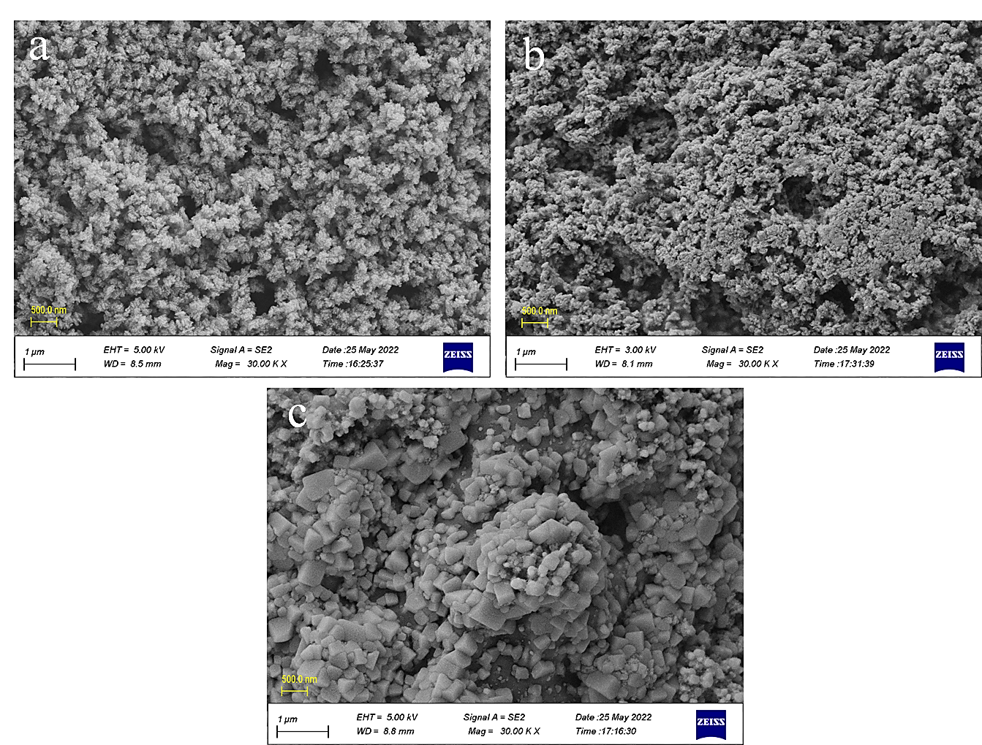
Figure 3. The FESEM images of (a) TiO₂, (b) TiO₂-CS, and (c) TiO₂-CS-Ag at various magnifications.
Introduction of Ag particles within the matrix of TiO₂-CS nanocomposite has significantly changed its morphology. Flower-like species consisting of polygonal nanoparticles are observed in the FESEM image of the TiO₂-CS-Ag nanocomposite (Figures 3c). The size of polygonal nanoparticles is in the range from 89.02 nm to 341.2 nm.
As evidenced by Figure 4a illustrating the EDXS pattern of TiO₂ nanoparticles, the pronounced peak of oxygen (O) element is obvious at about 0.5 keV. In addition, the characteristic peaks of titanium (Ti) element are easily found at approximately 0.5 and 4.5 keV. The peaks of oxygen and titanium elements are originated from the TiO₂ nanoparticles. Like TiO₂, the EDXS pattern of TiO₂-CS nanocomposite reveal the peaks of oxygen and titanium elements relevant to TiO₂ nanoparticles (Figure 4b). Moreover, the peak of carbon (C) element can be detected at about 0.25 keV. The peaks of carbon as well as oxygen are associated with the presence of chitosan within the nanocomposite.
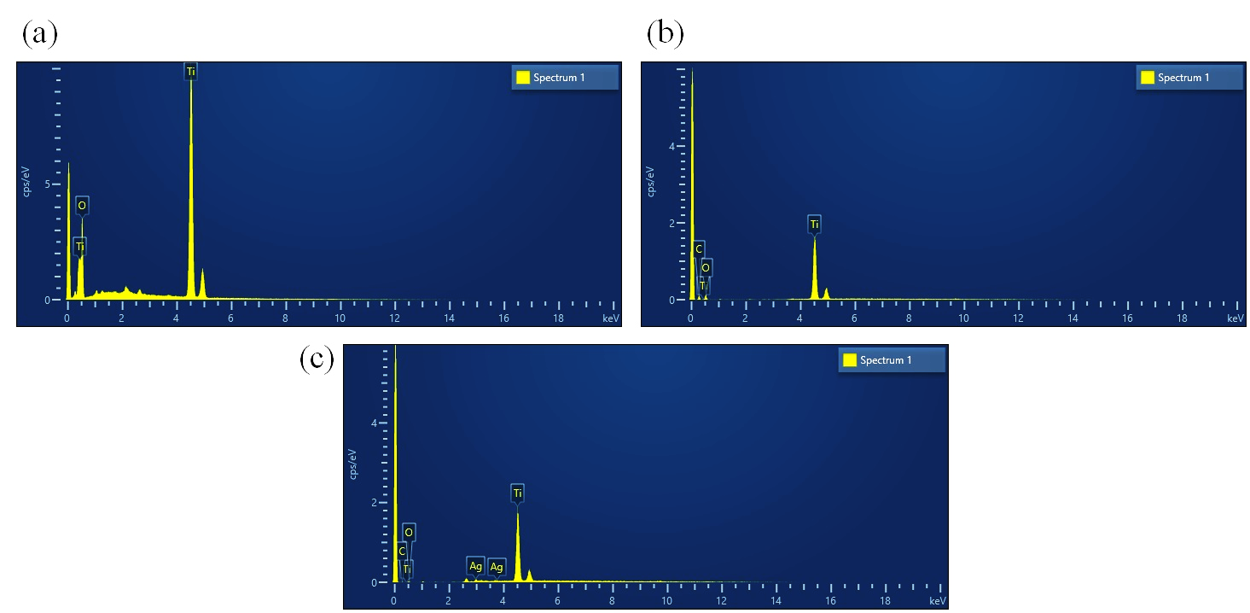
Figure 4. The EDXS patterns of (a) TiO₂, (b) TiO₂-CS, and (c) TiO₂-CS-Ag.
For the TiO₂-CS-Ag nanocomposite (Figure 4c), the peaks of oxygen and titanium elements showing TiO₂ nanoparticles and also the peaks of carbon and oxygen elements related to chitosan are distinguished. Additionally, the conspicuous peaks of silver (Ag) element are discernable at about 3.0 and 3.75 keV.
3.2. Specific surface area investigation
The specific surface area of TiO₂, TiO₂-CS, and TiO₂-CS-Ag was examined using BET analysis. Figure 5 demonstrates the nitrogen absorption-desorption isotherms for prepared samples. Besides, the results obtained from BET analysis are listed in Table 1.
Accordingly, all the samples show a mean pore diameter more than 50 nm, meaning that they are macropores. The average pore diameter achieved for TiO₂ nanoparticles is 2020.7 nm. Compositing TiO₂ with chitosan has resulted in an increment in mean pore diameter. In this regard, the sample with chitosan shows an average pore diameter of 85304 nm, more than the ones without chitosan (TiO₂ nanoparticles) and also with chitosan and Ag (TiO₂-CS-Ag nanocomposite). Introduction of Ag has brought about to a significant decrement in mean pore diameter and the sample with both chitosan and Ag demonstrated the least value. In terms of effective surface area, the highest value is obtained for TiO₂ nanoparticles composited with chitosan and included with Ag. This can be tied with the dimension of the nanocomposite where the least amount was calculated for TiO₂-CS-Ag, as evidenced by XRD analysis. Smaller size provides more active surface area. Interestingly, TiO₂-CS nanocomposite reached an effective surface area less than its counterpart without chitosan.
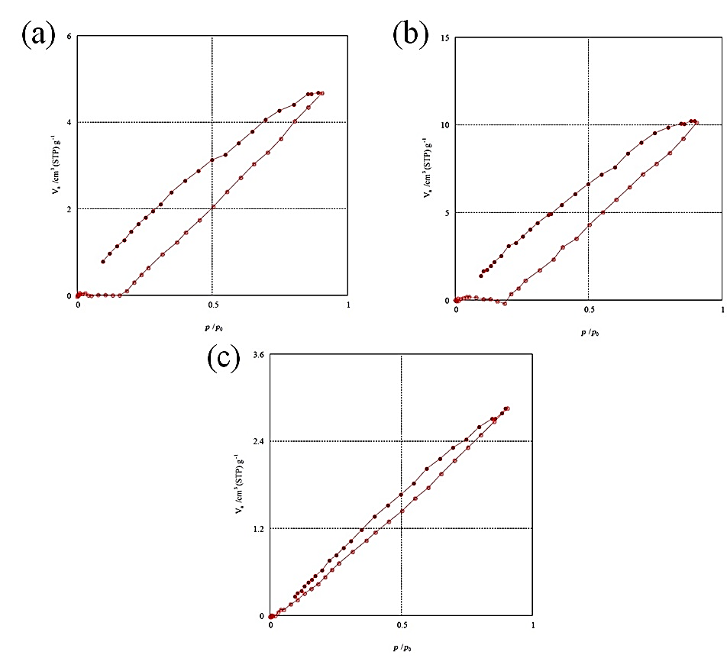
Figure 5. Nitrogen absorption-desorption isotherm of (a) TiO₂, (b) TiO₂-CS, and (c) TiO₂-CS-Ag.
Table 1. Data obtained from BET analysis conducted for TiO₂, TiO₂-CS, and TiO₂-CS-Ag.
Sample | Mean pore diameter  (nm) | Effective pore volume (cm³/g) | Effective surface area (m²/g)
TiO₂ | 2020.7 | 0.0072335 | 0.014319
TiO₂-CS | 85304 | 0.015655 | 0.00073408
TiO₂-CS-Ag | 106.48 | 0.0044144 | 0.16582
In addition to BET, BJH analysis was conducted to study pore size distribution. According to BJH absorption (Figure 6a) and desorption (Figure 6b) curves of TiO₂ nanoparticles, both mesopores (2–50 nm) and macropores (>50 nm) can be found. Compositing TiO₂ with chitosan had negligible effect on pore size distribution.
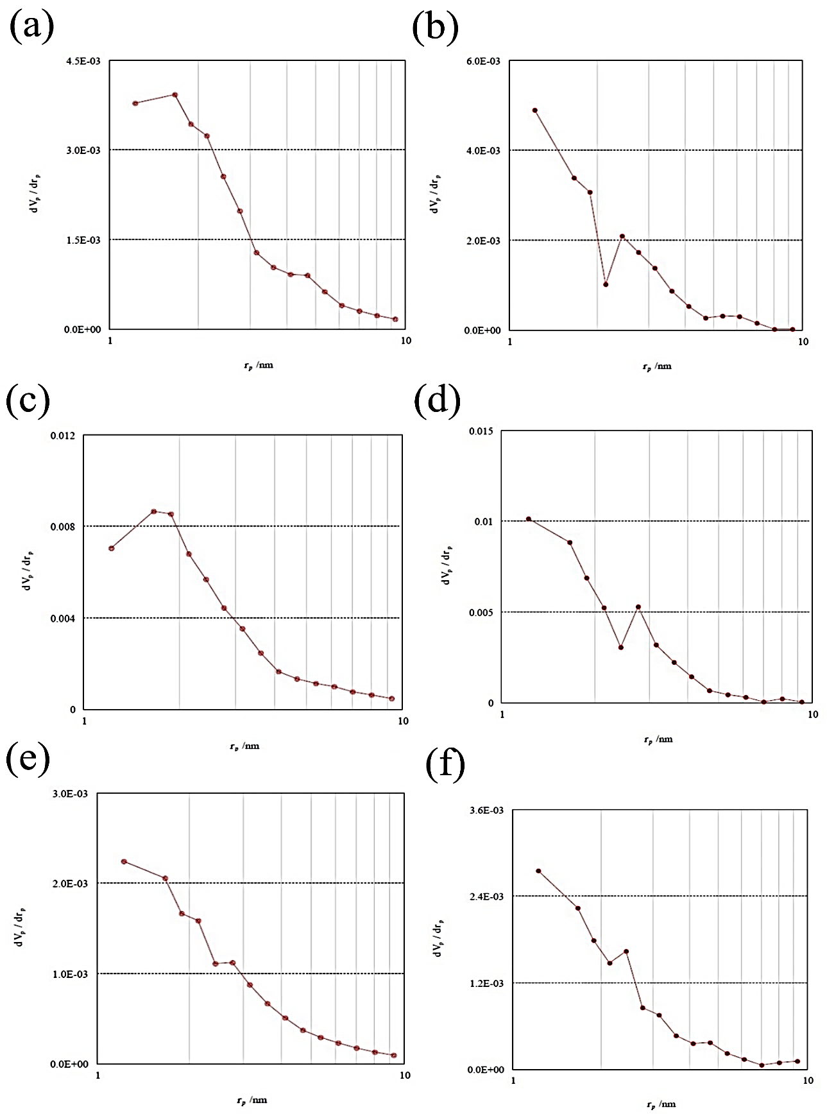
Figure 6. The BJH curves for (a,b) TiO₂, (c,d) TiO₂-CS, and (e,f) TiO₂-CS-Ag. For each sample, the first and second curve is respectively absorption and desorption.
Like TiO₂, the BJH absorption (Figure 6c) and desorption (Figure 6d) curves of TiO₂-CS nanocomposite demonstrate a mixture of mesopores and macropores. Mixing TiO₂ nanoparticles with CS has resulted in an increment in pore volume. Introduction of Ag within TiO₂-CS nanocomposite decreased the pore volume. The TiO₂-CS-Ag nanocomposite also showed a combination of mesopores and macropores (Figures 6e, f).
3.3. Antibacterial activity measurements
Antibacterial activities of TiO₂, TiO₂-CS, and TiO₂-CS-Ag against E. coli and S. aureus respectively as gram-negative and gram-positive bacteria were examined by means of disk diffusion method. This technique is typically carried out through spreading the microorganism on an agar culture medium and then, placing the antibacterial agent on the medium as a spot. The antibacterial agents are expected to inhibit the germination and prevent the growth of microorganism. The circular area around the spot of antibacterial agent or in other words, the zone of inhibition is measured as a parameter for examining the effectiveness of antibacterial agent. Higher size of inhibition zone means more susceptibility of microorganism toward antibacterial agent.
Figure 7 demonstrates the disk diffusion test carried out for TiO₂, TiO₂-CS and TiO₂-CS-Ag against E. coli. Accordingly, the highest size of inhibition zone after 24 hours is observed for TiO₂-CS-Ag nanocomposite among all the samples. As a result, TiO₂-CS-Ag takes advantage of high antibacterial activity against E. coli. No zone of inhibition can be detected for the blank sample and also TiO₂ nanoparticles. Therefore, they lack of any antibacterial activity against E. coli. On the other hand, compositing TiO₂ nanoparticles with chitosan has gave rise to appearance of zone of inhibition, which is smaller than the one seen for TiO₂-CS-Ag nanocomposite.
High antibacterial activity of TiO₂-CS-Ag nanocomposite against E. coli can be related to two reasons, one of which is the presence of silver particles acting as powerful antibacterial agents against both gram-positive and gram-negative bacteria [10]. The other reason is the role of both chitosan and Ag in reducing the size of TiO₂ nanoparticles and subsequently, increasing their surface area, as evidenced by both XRD and BET analyses.
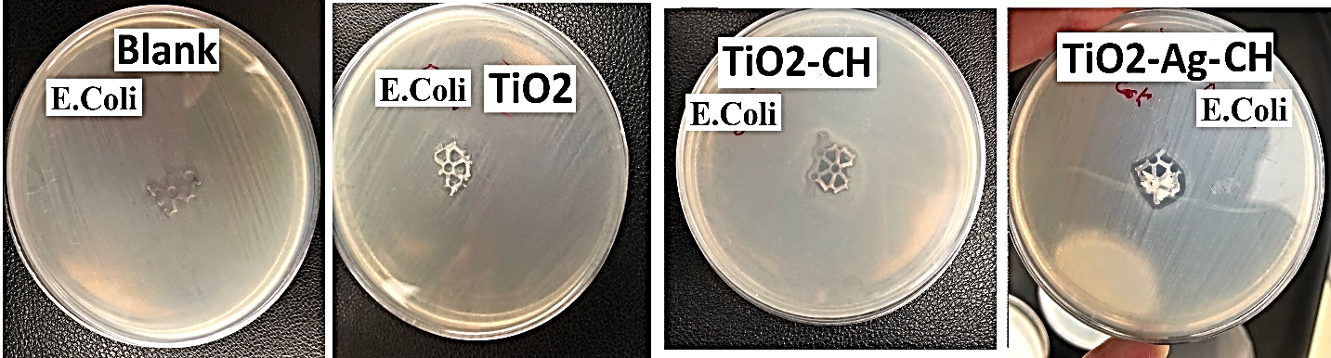
Figure 7. Zone of inhibition obtained for the disks without case study samples and with TiO₂, TiO₂-CS and TiO₂-CS-Ag against E. coli.
In addition to E. coli, the antibacterial activity of our prepared samples was investigated against S. aureus as a gram-positive bacterium. Figure 8 exhibits the zone of inhibition recorded for TiO₂, TiO₂-CS and TiO₂-CS-Ag against S. aureus after 24 hours.
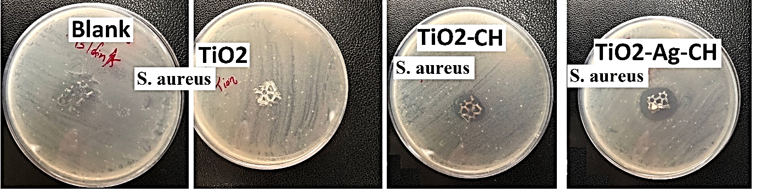
Figure 8. Zone of inhibition recorded for the disks without case study samples and with TiO₂, TiO₂-CS and TiO₂-CS-Ag against S. aureus.
Accordingly, the highest size of inhibition zone is shown by TiO₂-CS-Ag nanocomposite, meaning that this sample could appear as antibacterial agent against gram-positive bacteria. Like TiO₂-CS-Ag nanocomposite, its counterpart without Ag particles shows antibacterial activities against S. aureus. On the other hand, no inhibition zone can be detected for TiO₂ nanoparticles; as a consequence, this sample exhibits no antibacterial activities against S. aureus. The results obtained from antibacterial activity measurements corroborates that TiO₂-CS-Ag nanocomposite could be an ideal antibacterial agent against both gram-negative and gram-positive bacteria.

4. Conclusions
In this work, TiO₂ nanoparticles along with their nanocomposites, including TiO₂-CS and TiO₂-CS-Ag, were synthesized to examine their applicability as antibacterial agents. All the characterization tests were verified the synthesis of the samples. In accordance with XRD test, including solely chitosan or both chitosan and Ag into TiO₂ nanoparticles changed their X-ray diffractogram.. Besides, the nanocomposites exhibited less average size compared to nanoparticles. FTIR spectroscopy confirmed more the preparation of samples where the characteristic peaks relevant to each of TiO₂, chitosan and Ag were observed. TiO₂ nanoparticles and their composite with chitosan showed almost a similar morphology. However, inclusion of Ag into TiO₂-CS nanocomposite changed completely its morphology.
Among all the samples, only TiO₂-CS and TiO₂-CS-Ag nanocomposites revealed antibacterial activity against E. coli and S. aureus bacteria where the highest effectiveness was obtained for the one with Ag. The reason for excellent antibacterial activity of TiO₂-CS-Ag nanocomposites was arisen from the presence of Ag particles and also its high surface area, as was verified by BET analysis. The results of our study put forward that TiO₂-CS-Ag nanocomposites could be ideal for medical applications. They can be adopted to surmount the health issues originated from E. coli and S. aureus bacteria.

6. References
1. Nagaraj, G., et al., Facile synthesis of improved anatase TiO 2 nanoparticles for enhanced solar-light driven photocatalyst. SN Applied Sciences, 2020. 2: p. 1-9.
2. Jamil, S. and M. Fasehullah, Effect of temperature on structure, morphology, and optical properties of TiO2 nanoparticles. Mater Innov, 2021. 1(01): p. 22-8.
3. Mallick, S., et al., PLA-TiO2 nanocomposites: Thermal, morphological, structural, and humidity sensing properties. Ceramics International, 2018. 44(14): p. 16507-16513.
4. Tamarani, A., R. Zainul, and I. Dewata. Preparation and characterization of XRD nano Cu-TiO2 using sol-gel method. in Journal of Physics: Conference Series. 2019. IOP Publishing.
5. Castillo, B.E., et al., Potential use of chitosan-TiO2 nanocomposites for the electroanalytical detection of imidacloprid. Polymers, 2022. 14(9): p. 1686.
6. Taspika, M., et al., Influence of TiO2/Ag particles on the properties of chitosan film. Advances in Natural Sciences: Nanoscience and Nanotechnology, 2020. 11(1): p. 015017.
7. El-Desoky, M., et al., Synthesis, structural and electrical properties of PVA/TiO2 nanocomposite films with different TiO2 phases prepared by sol–gel technique. Journal of Materials Science: Materials in Electronics, 2020. 31(20): p. 17574-17584.
8. Deyab, M., A.A. Nada, and A. Hamdy, Comparative study on the corrosion and mechanical properties of nano-composite coatings incorporated with TiO2 nano-particles, TiO2 nano-tubes, and ZnO nano-flowers. Progress in Organic Coatings, 2017. 105: p. 245-251.
9. Zhang, B., Y. Luo, and Q. Wang, Development of silver/α-lactalbumin nanocomposites: a new approach to reduce silver toxicity. International journal of antimicrobial agents, 2011. 38(6): p. 502-509.
10. Li, J., Xie, B., Xia, K., Li, Y., Han, J. and Zhao, C., Enhanced antibacterial activity of silver doped titanium dioxide-chitosan composites under visible light. Materials, 2018. 11(8): p.1403.
11. Dong, Z., Li, R. and Gong, Y., Antibacterial and freshness-preserving mechanisms of chitosan-nano-TiO₂-nano-Ag composite materials. Coatings, 2021. 11(8): p.914.
12. Zafar, N., Uzair, B., Niazi, M.B.K., Samin, G., Bano, A., Jamil, N., Sajjad, S. and Menaa, F., Synthesis and characterization of potent and safe ciprofloxacin-loaded Ag/TiO₂/CS nanohybrid against mastitis causing E. coli. Crystals, 2021, 11:p.319.
13. Abutalib, M.M. and Rajeh, A.J.P.T., Enhanced structural, electrical, mechanical properties and antibacterial activity of Cs/PEO doped mixed nanoparticles (Ag/TiO₂) for food packaging applications. Polymer Testing, 2021. 93: p.107013.
14. Usman Khan, M., Rehman, W., Bibi, S., Alanazi, M.M., Alanazi, A.S., Rasheed, L., Khan, S., Tariq Gillani, S.U. and Tauqeer, A., Synthesis, characterization, and antimicrobial and nematicidal activities of chitosan-based silver-doped titanium dioxide. ACS omega, 2023. 8: pp.19341-19350.
15. Hoang, T.D., Nguyen, T.C., Doan, T.T., Ngo, T.D., Nguyen, T.Y., Ngo, B.T., Tran, T.T. and Le, T.L., Preparation and photocatalytic and antibacterial properties of polyvinyl alcohol/chitosan/TiO₂@Ag electrospun nanofibers. Thin Solid Films, 2024. 797: p.140344.
16. Lin, D., Yang, Y., Wang, J., Yan, W., Wu, Z., Chen, H., Zhang, Q., Wu, D., Qin, W. and Tu, Z., Preparation and characterization of TiO₂-Ag loaded fish gelatin-chitosan antibacterial composite film for food packaging. International Journal of Biological Macromolecules, 2020. 154: pp.123-133.
17. Rana, A., Parashar, S., Singh, D., Singh, K., Chanda, D., Pal, A., Srivastava, R. and Sharma, S.N., Exploring the dermal safety of green-synthesized Ag–TiO₂ nanocomposites for topical applications. RSC advances, 2025, 15(12): pp.9320-9334.
18. Zhang, C., Hua, H., Liu, J., Han, X., Liu, Q., Wei, Z., Shao, C. and Hu, C., Enhanced photocatalytic activity of nanoparticle-aggregated Ag–AgX (X=Cl,Br)@TiO₂ microspheres under visible light. Nano-Micro Letters, 2017, 9(4): p.49.

